**System architecure**

The system architecure diagram is shown in Figure 1.

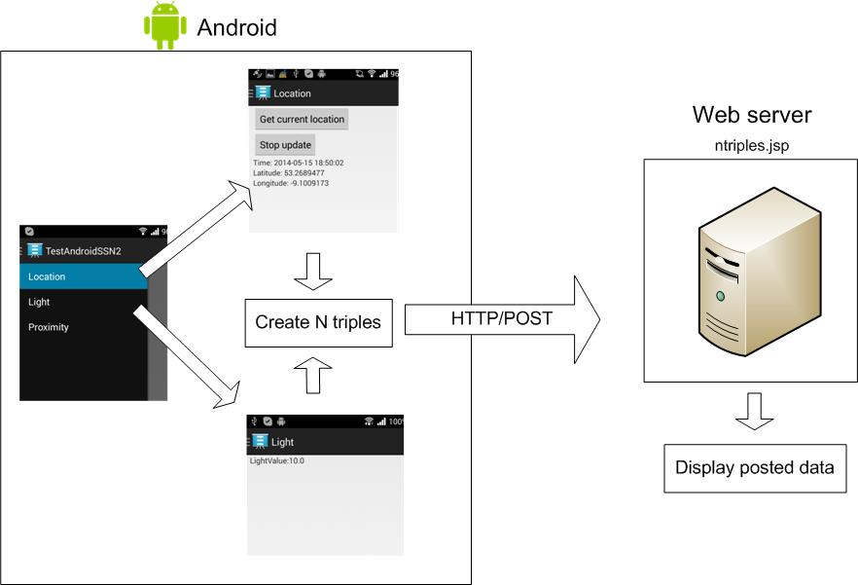

Figure 1 System architecture

Currently, the user needs to select sensor types from the menu as shown in Figure 2.

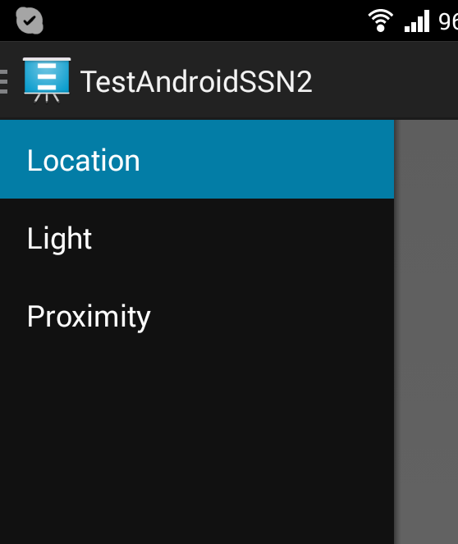

Figure 2 Menu list

**Location sensor:**

To get the current location, the user needs to press [Get current location] button. Once the button is clicked, location data such as reading time, latitude and longitude is read and the data is created in N triple format and send it to web server via HTTP/POST. Currently, the update interval is set to 5 seconds and when the [stop update] button is clicked, it stops reading location data.

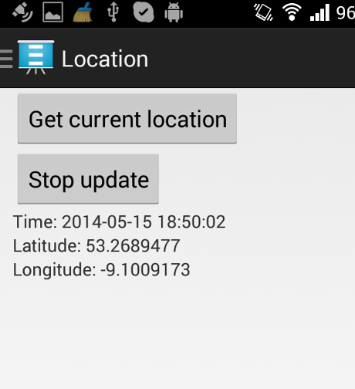

Figure 3 Location sensor

**Light sensor:**

Once the light sensor is selected from the menu, it starts reading light values and creating N triples.

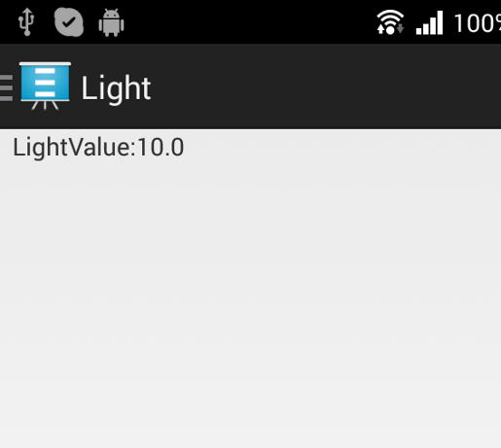

Figure 4 Light sensor

**Web server:**

The web server receives N triple formatted data and just displays it on a browser.

**N triple formatted data:**

The example N triple formatted data is shown in Figure 5. Currently the first time any sensor data is sent, the platform is sent. The first time each sensor data is sent, the sensor type is sent. Each measurement from a sensor uses an increamented measurement property, e,g, measurement 1 and measurement2…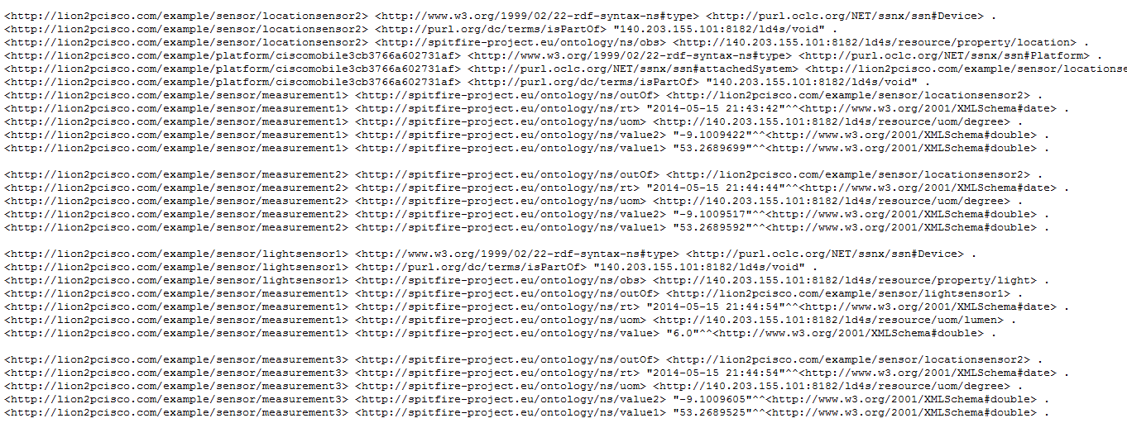

Figure 5 N triple formatted data

Platform: platform/”***ciscomobile”+ android ID*** (device ID).

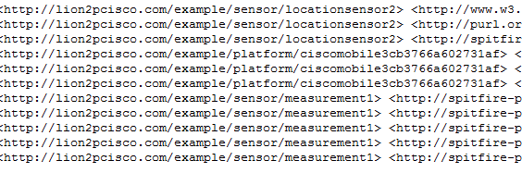

Figure 6 platform

Sensor: sensor*/****locationsensor2*** or *sensor/****lightsensor1,*** but it will change to sensor/***device ID + sensor type***, e.g. “location” and “light”



Measurement**:** sensor/***measurement + integer number***. It will change to sensor/***device ID + sensor type+ “measurement” + timestamp***



**Android Sensor Overview**

The following table shows a list of sensor types supported by the Android platform. (See details: <http://developer.android.com/guide/topics/sensors/sensors_overview.html>

|  |  |  |  |
| --- | --- | --- | --- |
| **Sensor** | **Description** | **Common Uses** | **Implemented** |
| Location | Measure latitude and longitude in degree |  | Already  implemented |
| **Sensor** | **Description** | **Common Uses** | **Implemented** |
| TYPE_ACCELEROMETER | Measures the acceleration force in m/s2 that is applied to a device on all three physical axes (**x, y, and z**), including the force of gravity. | Motion detection (shake, tilt, etc.). |  |
| TYPE_GRAVITY | Measures the force of gravity in m/s2 that is applied to a device on all three physical axes (**x, y, z**). | Motion detection (shake, tilt, etc.). |  |
| TYPE_GYROSCOPE | Measures a device's rate of rotation in rad/s around each of the three physical axes (**x, y, and z**). | Rotation detection (spin, turn, etc.). |  |
| TYPE_LIGHT | Measures the ambient light level (illumination) in **lx**. | Controlling screen brightness. | Already  implemented |
| TYPE_LINEAR_ACCELERATION | Measures the acceleration force in m/s2 that is applied to a device on all three physical axes (x, y, and z), excluding the force of gravity. | Monitoring acceleration along a single axis. |  |
| TYPE_MAGNETIC_FIELD | Measures the ambient geomagnetic field for all three physical axes (x, y, z) in **μT**. | Creating a compass. |  |
| TYPE_PROXIMITY | Measures the proximity of an object in cm relative to the view screen of a device. This sensor is typically used to determine whether a handset is being held up to a person's ear. | Phone position during a call. | will implement |
| TYPE_ROTATION_VECTOR | Measures the orientation of a device by providing the three elements of the device's rotation vector. | Motion detection and rotation detection. |  |

The following sensor also are supported but depends on devices (my phone, Sony Xperia T doesn’t support)

|  |  |  |
| --- | --- | --- |
| **Sensor** | **Description** | **Common Uses** |
| TYPE_AMBIENT_TEMPERATURE | Measures the ambient room temperature in degrees Celsius (°C). See note below. | Monitoring air temperatures. |
| TYPE_PRESSURE | Measures the ambient air pressure in hPa or mbar. | Monitoring air pressure changes. |
| TYPE_RELATIVE_HUMIDITY | Measures the relative ambient humidity in percent (%). | Monitoring dewpoint, absolute, and relative humidity. |
| TYPE_TEMPERATURE | Measures the temperature of the device in degrees Celsius (°C).  This sensor implementation varies across devices and this sensor was replaced with the TYPE_AMBIENT_TEMPERATURE sensor in API Level 14 | Monitoring temperatures. |